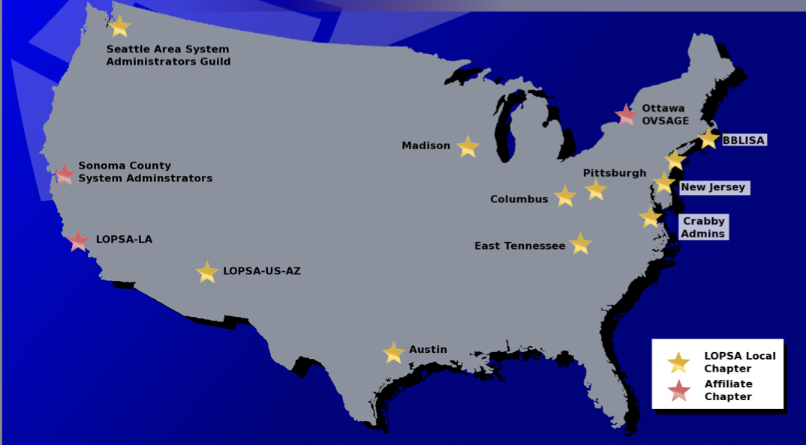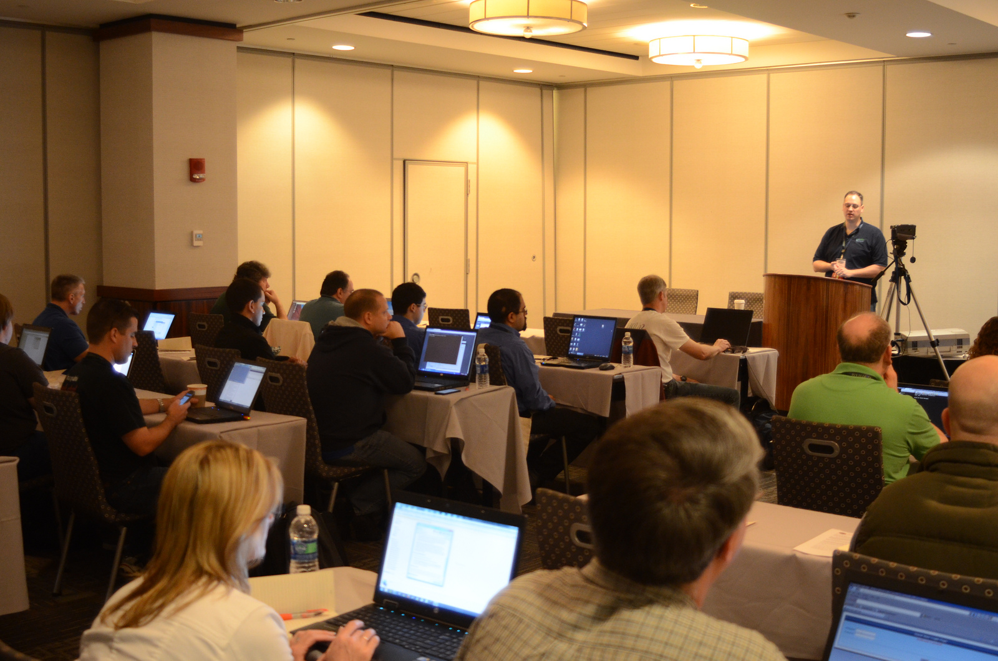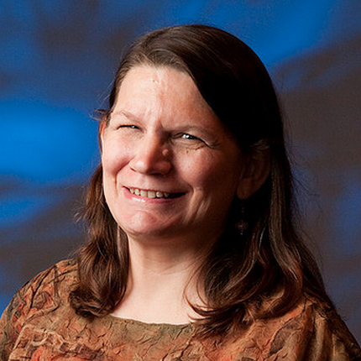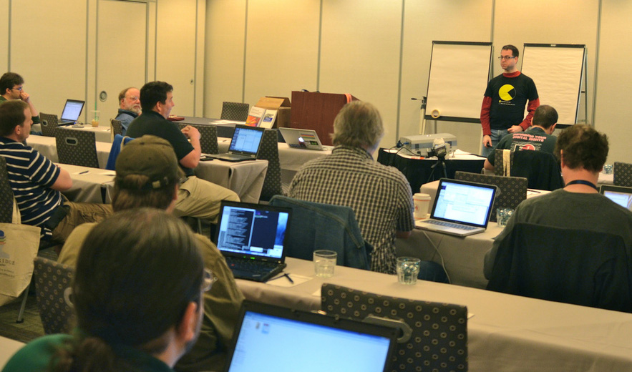

***http://lopsa.org***

The chapter in your town is the latest in a growing number of LOPSA groups that are cropping up around the country & world.

LOPSA has members from over 43 countries all over the globe, and among them are the best, brightest system administrators.

Membership in LOPSA has continually grown since our inception because of the hard work by our board, our members and the support of our sponsors.

### LOPSA Chapters exist throughout North America…

…and we’re always looking for more.

Please contact us at:

*To advance the practice of*

*system administration…*

## LOPSA is an organization you should be involved in.

## Professionalism…

## Community…

## Service…

***corporate***

***sponsorship***

***opportunities***

# *Leagues ahead…*

What is LOPSA?

We are a professional organization for system administrators and other IT professionals who are interested in improving their skills.

LOPSA was established in 2005 as a 501(c)(3) organization, a designation which is shared by our local chapters. As such, a percentage of any sponsorships may be tax-deductible.

We have various programs in place to help our members and the rest of the community. Efforts such as our Mentorship program provide real benefits to the larger community of system administrators

LOPSA is dedicated to improving the art and practice of system administration. One of the primary ways we do that is through our local chapters.

By supporting your local chapter, you not only help LOPSA, but you forge a solid and lasting relationship with the professional IT Administrators who make up the community in your neighborhood.

Our meetings are generally focused around a technical presentation by a member of the community, or a representative from an organization of interest to system administrators.

There are a number of opportunities for our organizations to work together. Here are some things that our sponsors have helped us with in the past:

* Held a meeting in their office
* Sponsored before-meeting refreshments such as pizza & soda
* Given us a tour of their datacenter
* Provided giveaway items such as software, books, magazines, etc.
* Financial donations at either the local or International level